
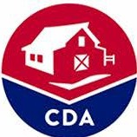
COLORADO

Department of Agriculture

This facility is licensed and regulated by the

Colorado Department of Agriculture Pet Care Program (PACFA)
Please contact the program with comments or questions

303-869-9146 or CDA_PACFA@state.co.us

"PSafeAguardinCg ColoFrado's Pets

